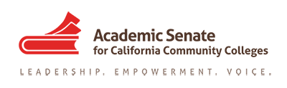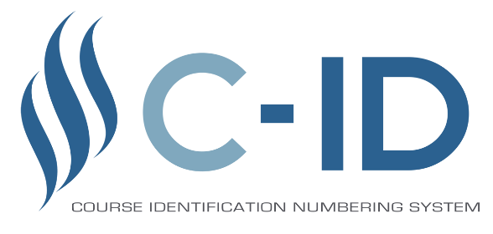

Greetings Faculty,

At present, new work in the C-ID for CTE and model curriculum realm is on hiatus. The disciplines with work that is in progress need to complete their tasks by the end of May. During the years ahead, discussions will be held to explore how to move this work forward – or sunset aspects of it. A formal evaluation process will be initiated and concluded during the 2022-2023 academic year, resulting in a new strategic plan for the work.

At present, the priorities for this work are defined in the ASCCC Strategic Plan (2018-2023). The ASCCC is committed to the following:

- Evaluate and recommend methods to improve CTE C-ID efforts.
- Expand the number of certificate and degree Model Curricula
- Evaluate and implement competency based models of student achievement in C-ID processes.

This hiatus and evaluation has been initiated because of significant changes in the priorities of the CCCCO, concerns about the value of this work for some CTE disciplines, and questions about how to move this work forward.

If you have any questions or concerns, please share them with us at info@asccc.org. Your feedback – and questions – are appreciated.

Regards,
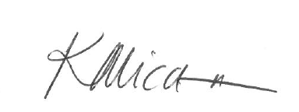
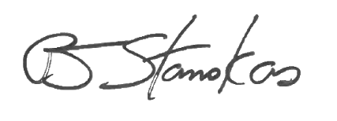

President, John Stanskas Executive Director, Krystinne Mica

