STATE OF CALIFORNIA | ELOY ORTIZ OAKLEY, CHANCELLOR
California Community Colleges  Chancellor’s Office  1102 Q street, Suite 4400  Sacramento, Ca 95811-6549  (916) 322-4005  http://www.cccco.edu | 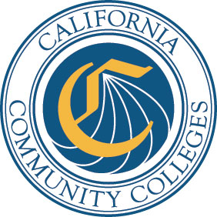

DATE: December 12, 2017 AA 17-64
VIA E-MAIL

TO: Chief Executive Officers
Chief Instructional Officers
Academic Senate for California Community Colleges
Articulation Officers
Curriculum Specialists

FROM: Alice Perez
Vice Chancellor, Academic Affairs

SUBJECT: SOCIAL JUSTICE STUDIES ASSOCIATE DEGREES FOR TRANSFER
Senate Bill 440 required the creation of four Transfer Model Curriculum’s (TMC) templates to allow students a broader area of study than previously available in other Associate Degrees for Transfer (ADTs). As of September, all four TMCs, Global Studies; Law, Public Policy, and Society; Social Justice; and Social Work and Human Services, have been posted to the Chancellor’s Office website, Academic Affairs Division, Templates For Approved Transfer Model Curriculum webpage.
In regards to Social Justice Studies, colleges have asked for the ability to have areas of focus. In response, the Chancellor’s Office, with consultation from the California Community College Curriculum Committee (5C) and the Academic Senate for California Community Colleges, has decided to create four additional unique TOP Codes. These additional TOP Codes will allow colleges the ability to create ADTs in areas of focus within the Social Justice Studies: General ADT. If a college does decide to create a Social Justice Studies ADT in any one of the five areas, there is no requirement that the college has to create an ADT in the other four areas of Social Justice Studies. The list of the TOP Codes with the titles of the specified areas are listed below.
TOP Code | Title | CIP
2201.30 | Social Justice Studies: General | 05.0299
2201.40 | Social Justice Studies: Chicano Studies | 05.0203
2201.50 | Social Justice Studies: Ethnic Studies | 05.0200
2201.60 | Social Justice Studies: LGBTQ Studies | 05.0208
2201.70 | Social Justice Studies: Gender Studies | 05.0207
Social Justice Studies Associate Degrees for Transfer
December 12, 2017
Page 2

The current TMC template posted to the Chancellor’s Office website will be used for all five Social Justice Studies ADTs with the colleges selecting the appropriate TOP Code and title for their Social Justice Studies program when entering the data in the Chancellor’s Office Curriculum Inventory system.

For questions, contact Dean Jackie Escajeda at jescajeda@cccco.edu or at 916-327-2066.

